# ExploSim - Reducing Brain Injuries

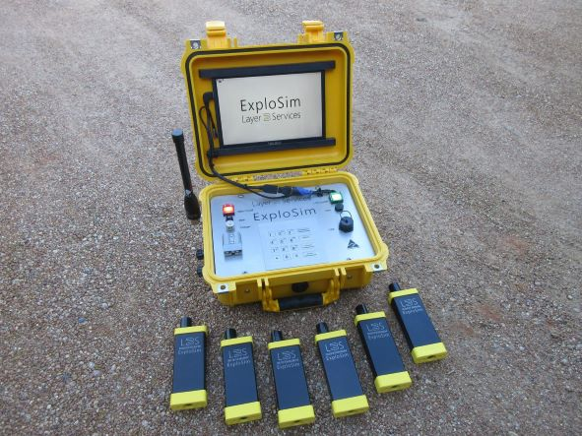Repeated exposure to blast overpressure in training or on operations can lead to mild Traumatic Brain Injury (mTBI). The ExploSim system reduces the need for exposure during education, training and operational rehearsal. Students can ‘see’ the effects of an explosion without suffering the consequences and learn ‘how close is too close’.

The ExploSim system uses RF to provide immediate feedback of the blast and fragmentation effects. The transmitter is used to select the type and amount of explosive and can be connected to a training device. The receivers are worn by participants (or placed on critical equipment, support vehicles and against structures).

The ExploSim system registers blast effects upwards of 27.5 kPa (4 psi).

ExploSim is Australian designed and manufactured; uses no energetic materials and is safe to use wherever WIFI is permitted. It does not need firing ranges and is not affected by fire restrictions. ExploSim is used to augment classroom instruction on explosive effects.

In risk terms we are certainly reducing the risk of “Personnel experiencing mTBI” by “Reducing the likelihood of exposure to overpressures by teaching them how close is too close through practical experience using non-injurious WIFI to emulate blast effects and also by reducing the number of times they need to be subjected to blast during training and rehearsal.”

For the first time, a system exists which provides immediate indication of explosive effects in a safe manner when training users of explosives. ExploSim provides a means to comply with the requirements and recommendations of the BOSA and RCVS recommendations.

Videos of the system are at [www.youtube.com/@layer3services](http://www.youtube.com/@layer3services) or visit our offices in Fyshwick, Canberra.

Layer 3 Services is a member of Medical Technology Enterprise Consortium ( <https://mtec-sc.org/> ).